**Query for Problem:**

|  |
| --- |
| DELETE FROM LOCATION  WHERE LOCNO = ‘L108’; |

**Snapshot for the Problem:**

1. **Before Updating the query**

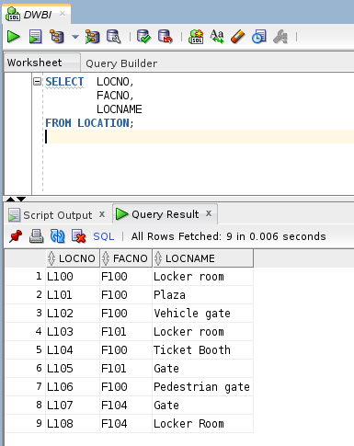

1. **Executing the Delete query**

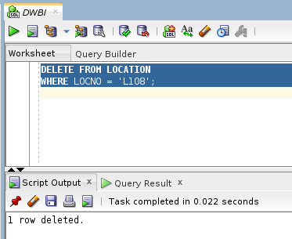

1. **After executing the query**